MILLION’S OF
YEARS AGO
4,000 | The earliest life appears.  Further information: Origin of life
3,900 | Cells resembling prokaryotes appear.  Further information: Cell (biology)#Origins of cells
2,500 | First organisms to utilize oxygen.
2,100 | More complex cells appear: the eukaryotes.  Further information: Eukaryote#Origin and evolution
1,200 | Sexual reproduction evolves, leading to faster evolution.^{[1]}
900 | 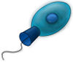  Choanoflagellate  The choanoflagellates may look similar to the ancestors of the entire animal kingdom, and in particular they may be the direct ancestors of sponges.^{[2]} Proterospongia (members of the Choanoflagellata) are the best living examples of what the ancestor of all animals may have looked like. They live in colonies, and show a primitive level of cellular specialization for different tasks.
600 | It is thought that the earliest multicellular animal was a sponge-like creature. Sponges are among the simplest of animals, with partially differentiated tissues. Sponges (Porifera) are the phylogenetically oldest animal phylum extant today.
580 | The movement of all animals may have started with cnidarians. Almost all cnidarians possess nerves and muscles and, because they are the simplest animals to possess it, their direct ancestors were very likely the first animals to use nerves and muscles together. Cnidarians are also the first animals with an actual body of definite form and shape. They have radial symmetry.
550 | Flatworm  Flatworms are the earliest animals to have a brain, and the simplest animals alive to have bilateral symmetry. They are also the simplest animals with organs that form from three germ layers.
540 | Acorn worms are considered more highly specialised and advanced than other similarly shaped worm-like creatures. They have a circulatory system with a heart that also functions as a kidney. Acorn worms have a gill-like structure used for breathing, a structure similar to that of primitive fish. Acorn worms are thus sometimes said to be a link between vertebrates and invertebrates.
530 | Pikaia  The earliest known ancestor of the chordates is Pikaia. It is the first known animal with a notochord. Pikaia is believed to be the ancestor of all chordates and vertebrates.^{[3]} The Lancelet, still living today, retains some characteristics of the primitive chordates. It resembles Pikaia. Other earliest known chordate-like fossils is from a conodonts a "eel-shaped animal of 4-20 cm (1½-8 in) long" with a pair of huge eyes at the head end were and a complex basket of teeth.
505 | Agnatha  The first vertebrates appear: the ostracoderms, jawless fish related to present-day lampreys and hagfishes. Haikouichthys and Myllokunmingia are examples of these jawless fish, or Agnatha. (See also prehistoric fish). They were jawless and their internal skeletons were cartilaginous. They lacked the paired (pectoral and pelvic) fins of more advanced fish. They were the Precursors to the bony fish. ^{[4]}
480 | 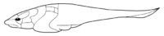  A Placoderm  The Placodermi were prehistoric fishes. Placoderms were the first of the jawed fishes, their jaws evolving from the first of their gill arches ^{[5]}. Their head and thorax were covered by articulated armoured plates and the rest of the body was scaled or naked.
400 | First Coelacanth appears; this order of animals had been thought to have no extant members until living specimens were discovered in 1938. It is often referred to as a living fossil.
375 | Tiktaalik is a genus of sarcopterygian (lobe-finned) fishes from the late Devonian with many tetrapod-like features.
365 | Panderichthys  Some fresh water lobe-finned fish (Sarcopterygii) develop legs and give rise to the Tetrapoda. The first tetrapods evolved in shallow and swampy freshwater habitats. Primitive tetrapods developed from a lobe-finned fish (an "osteolepid Sarcopterygian"), with a two-lobed brain in a flattened skull, a wide mouth and a short snout, whose upward-facing eyes show that it was a bottom-dweller, and which had already developed adaptations of fins with fleshy bases and bones. The "living fossil" coelacanth is a related lobe-finned fish without these shallow-water adaptations. These fishes used their fins as paddles in shallow-water habitats choked with plants and detritus. The universal tetrapod characteristics of front limbs that bend backward at the elbow and hind limbs that bend forward at the knee can plausibly be traced to early tetrapods living in shallow water.^{[6]}  Panderichthys is a 90-130 cm (35-50 in) long fish from the Late Devonian period. It has a large tetrapod-like head. Panderichthys exhibits features transitional between lobe-finned fishes and early tetrapods. Lungfishes retain some characteristics of the early Tetrapodas. One example is the Australian Lungfish.
315 | Acanthostega  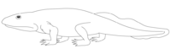  Ichthyostega  Acanthostega is an extinct amphibian, among the first animals to have recognizable limbs. It is a candidate for being one of the first vertebrates to be capable of coming onto land. It lacked wrists, and was generally poorly adapted for life on land. The limbs could not support the animal's weight. Acanthostega had both lungs and gills, also indicating it was a link between lobe-finned fish and terrestrial vertebrates.  Ichthyostega is an early tetrapod. Being one of the first animals with legs, arms, and finger bones, Ichthyostega is seen as a hybrid between a fish and an amphibian. Ichthyostega' had legs but its limbs probably weren't used for walking, they may have spent very brief periods out of water and would have used their legs to paw their way through the mud.^{[7]}  Amphibia were the first four-legged animals to develop lungs. Amphibians living today still retain many characteristics of the early tetrapods.
300 | 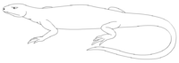  Hylonomus  From amphibians came the first reptiles: Hylonomus is the earliest known reptile. It was 20 cm (8 in) long (including the tail) and probably would have looked rather similar to modern lizards. It had small sharp teeth and probably ate millipedes and early insects. It is a precursor of later amniotes and mammal-like reptiles.  Evolution of the amniotic egg gives rise to the Amniota, reptiles that can reproduce on land and lay eggs on dry land. They did not need to return to water for reproduction. This adaptation gave them the capability to colonize the uplands for the first time.  Reptiles have advanced nervous system, compared to amphibians. They have twelve pairs of cranial nerves.
256 | 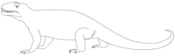  Phtinosuchus, an early Therapsid  Shortly after the appearance of the first reptiles, two branches split off. One branch is the Diapsida from which come the modern reptiles. The other branch is Synapsida which had temporal fenestra, a pair of holes in their skulls behind the eyes, which were used to increase the space for jaw muscles.  The earliest mammal-like reptiles are the pelycosaurs. The pelycosaurs were the first animals to have temporal fenestra. Pelycosaurs are not Therapsida but soon they gave rise to them. The Therapsida are the direct ancestor of mammals.  The therapsids have temporal fenestrae larger and more mammal-like than pelycosaurs, their teeth show more serial differentiation; and later forms had evolved a secondary palate. A secondary palate enables the animal to eat and breathe at the same time and is a sign of a more active, perhaps warm-blooded, way of life. ^{[8]}
220 | One sub-group of therapsids, the cynodonts evolved more mammal-like characteristics. The jaws of cynodonts resemble modern mammal jaws. It is very likely this group of animals contains a species which is the direct ancestor of all modern mammals.^{[9]}
220 | 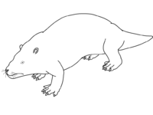  Repenomamus  From eucynodonts (cynodonts) came the first mammals. Most early mammals were small and shrew-like animals that fed on insects. Although there is no evidence in the fossil record, it is likely that these animals had a constant body temperature, milk glands for their young. The neocortex region of the brain first evolved in mammals and thus is unique to them.
125 | 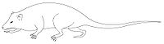  Eomaia scansoria  a eutherian mammal, leads to the formation of modern placental mammals. It looks like modern dormouse, climbing small shrubs in Liaoning, China.
100 | Common genetic ancestor of mice and humans.
65 | 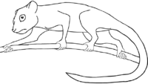  Carpolestes simpsoni  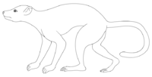  A Plesiadapis without fur.  A group of small, nocturnal and arboreal, insect-eating mammals called the Euarchonta begins a speciation that will lead to the primate, treeshrew and flying lemur orders. The Primatomorpha is a subdivision of Euarchonta that includes the primates and the proto-primate Plesiadapiformes. One of the early proto-primates is Plesiadapis. Plesiadapis still had claws and the eyes located on each side of the head, because of that they were faster on the ground than on the top of the trees, but they begin to spend long times on lower branches of trees, feeding on fruits and leaves. The Plesiadapiformes very likely contain the species which is the ancestor of all primates.^{[10]}  One of the last Plesiadapiformes is Carpolestes simpsoni. It had grasping digits but no forward facing eyes.
40 | Primates diverge into suborders Strepsirrhini (wet-nosed primates) and Haplorrhini (dry nosed primates). Strepsirrhini contains most of the prosimians; modern examples include the lemurs and lorises. The haplorrhines include the three living groups the prosimian tarsiers, the simian monkeys, and apes. One of the earliest haplorrhines is Teilhardina asiatica, a mouse-sized, diurnal creature with small eyes.
30 | 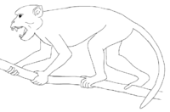  Aegyptopithecus  Haplorrhini splits into infraorders Platyrrhini and Catarrhini. Platyrrhines, New World monkeys, have prehensile tails and males are color blind. They may have migrated to South America on a raft of vegetation across the Atlantic ocean (circa 4,500 km, 2,800 mi). Catarrhines mostly stayed in Africa as the two continents drifted apart. One ancestor of catarrhines might be Aegyptopithecus.
25 | 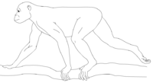  Proconsul  Catarrhini splits into 2 superfamilies, Old World monkeys (Cercopithecoidea) and apes (Hominoidea).  Proconsul was an early genus of catarrhine primates. They had a mixture of Old World monkey and ape characteristics. Proconsul's monkey-like features include thin tooth enamel, a light build with a narrow chest and short forelimbs, and an arboreal quadrupedal lifestyle. Its ape-like features are its lack of a tail, ape-like elbows, and a slightly larger brain relative to body size. Proconsul africanus is a possible ancestor of both great and lesser apes, and humans.
15 | Hominidae (great apes) speciate from the ancestors of the gibbon (lesser apes).
13 | Homininae ancestors speciate from the ancestors of the orangutan^{[11]}.  Pierolapithecus catalaunicus is believed to be a common ancestor of humans and the great apes or at least a species that brings us closer to a common ancestor than any previous fossil discovery.  Pierolapithecus had special adaptations for tree climbing, just as humans and other great apes do: a wide, flat ribcage, a stiff lower spine, flexible wrists, and shoulder blades that lie along its back.
10 | Hominini speciate from the ancestors of the gorillas.
7 | 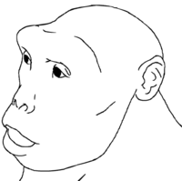  Sahelanthropus tchadensis  Hominina speciate from the ancestors of the chimpanzees. The latest common ancestor is Sahelanthropus tchadensis (ca. 7 Ma). The earliest known human ancestor post-dating the separation of the human and the chimpanzee lines is Orrorin tugenensis (Millennium Man, Kenya; ca. 6 Ma). Both chimpanzees and humans have a larynx that repositions during the first two years of life to a spot between the pharynx and the lungs, indicating that the common ancestors have this feature, a precursor of speech.
4.4 | Ardipithecus ramidus ramidus
4.4 | Some Australopithecus afarensis left footprints on volcanic ash in Laetoli, Kenya (Northern Tanzania) Strong evidence of bipedalism.
3.5 | 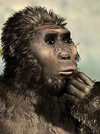  Kenyanthropus platyops, a possible ancestor of Homo, emerges from the Australopithecus genus.
3 | The bipedal australopithecines (a genus of the Hominina subtribe) evolve in the savannas of Africa being hunted by Dinofelis. Loss of body hair takes place in the period 3-2 Ma, in parallel with the development of full bipedalism.
2.5 | 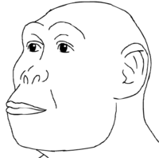  Homo habilis  Appearance of Homo. Homo habilis is thought to be the ancestor of the lankier and more sophisticated, Homo ergaster. Lived side by side the Homo erectus until at least 1.44 Ma, making it highly unlikely that Homo erectus directly evolved out of Homo habilis. First stone tools, beginning of the Lower Paleolithic.  Further information: Homo rudolfensis
1.8 | 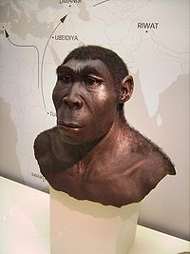  A reconstruction of Homo erectus.  Homo erectus evolves in Africa. Homo erectus would bear a striking resemblance to modern humans, but had a brain about 74 percent of the size of modern man. Its forehead is less sloping and the teeth are smaller. It is believed to be an ancestor of modern humans (with Homo heidelbergensis usually treated as an intermediary step).  Homo erectus migrates out of Africa and colonizes Eurasia.
1.5 | Dmanisi man / Homo georgicus (Georgia), tiny brain came from Africa, with Homo erectus and Homo habilis characteristics. Control of fire by early humans. Evolution of dark skin is complete by 1.2 Ma.
0.516 | Common genetic ancestor of humans and Neanderthal.^{[12]} At present estimate, humans have approximately 20,000–25,000 genes and share 99% of their DNA with the now extinct Neanderthal ^{[13]} and 95% of their DNA with their closest living evolutionary relative, the chimpanzees^{[14]}.
0.355 | 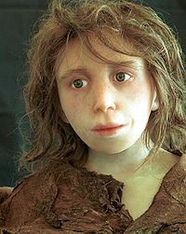  Reconstruction of a Neanderthal child from Gibraltar (Anthropological Institute, University of Zürich)  Three 1.5 m (5 ft) tall Homo heidelbergensis left footprints in powdery volcanic ash solidified in Italy. Homo heidelbergensis is the common ancestor of both Homo neanderthalensis and Homo sapiens. It is morphologically very similar to Homo erectus but Homo heidelbergensis had a larger brain-case, about 93% the size of that of Homo sapiens. The species was tall, 1.8 m (6 ft) on average, and more muscular than modern humans. Beginning of the Middle Paleolithic.
0.195 | Omo1, Omo2 (Ethiopia, Omo river) are the earliest fossil evidence for archaic Homo sapiens, evolved from Homo heidelbergensis.
0.160 | Homo sapiens (Homo sapiens idaltu) in Ethiopia, Awash River, Herto village, practise mortuary rituals and butcher hippos.
0.150 | 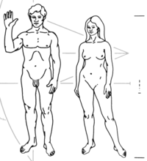  Homo sapiens sapiens (Pioneer plaque)  Mitochondrial Eve lives in East Africa. She is the most recent female ancestor common to all mitochondrial lineages in humans alive today.
0.70 | Appearance of mitochondrial haplogroup L2. Behavioral modernity. The FOXP2 gene (associated with the development of speech) appears in this period.^{[15]}
0.60 | Y-chromosomal Adam lives in Africa. He is the most recent common ancestor from whom all male human Y chromosomes are descended. Appearance of mitochondrial haplogroups M and N, which participate in the migration out of Africa.
0.50 | Migration to South Asia. M168 mutation (carried by all non-African males). Beginning of the Upper Paleolithic. mt-haplogroups U, K.
0.40 | Migration to Australia and Europe (Cro-Magnon).
0.25 | Neanderthals die out. Y-Haplogroup R2; mt-haplogroups J, X.
0.12 | Beginning of the Mesolithic / Holocene. Y-Haplogroup R1a; mt-haplogroups V, T. Evolution of light skin in Europeans (SLC24A5). First domestication of the dog. Homo floresiensis dies out, leaving Homo sapiens as the only living species of the genus Homo.
0.10 | Beginning of the Neolithic / Holocene. The invention of farming in the Fertile Crescent occurred during this time.

